**JECRC – 45 Days In-campus Training (4 Semester)**

**Subject – Full Stack Web Development**

# Day 5: 20th May, 2024

# Topic – float,shadow

**Assignment 3:-**

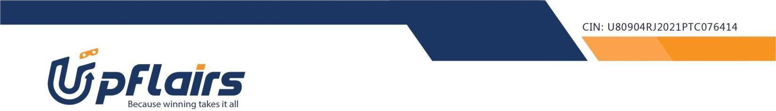 1. make this navigation bar using float

Note- write the code into single html file

Assignment submission form link - https://forms.gle/pePzygaadm6FktaS7